**PART 1**

|  |  |  |
| --- | --- | --- |
|  |  |  |
| (a) | (b) | (c) |

**Figure 1.** Screenshots of (a) elevation data, (b) PRISM ppt, and (c) GPM precipitation over the study area in Colorado.

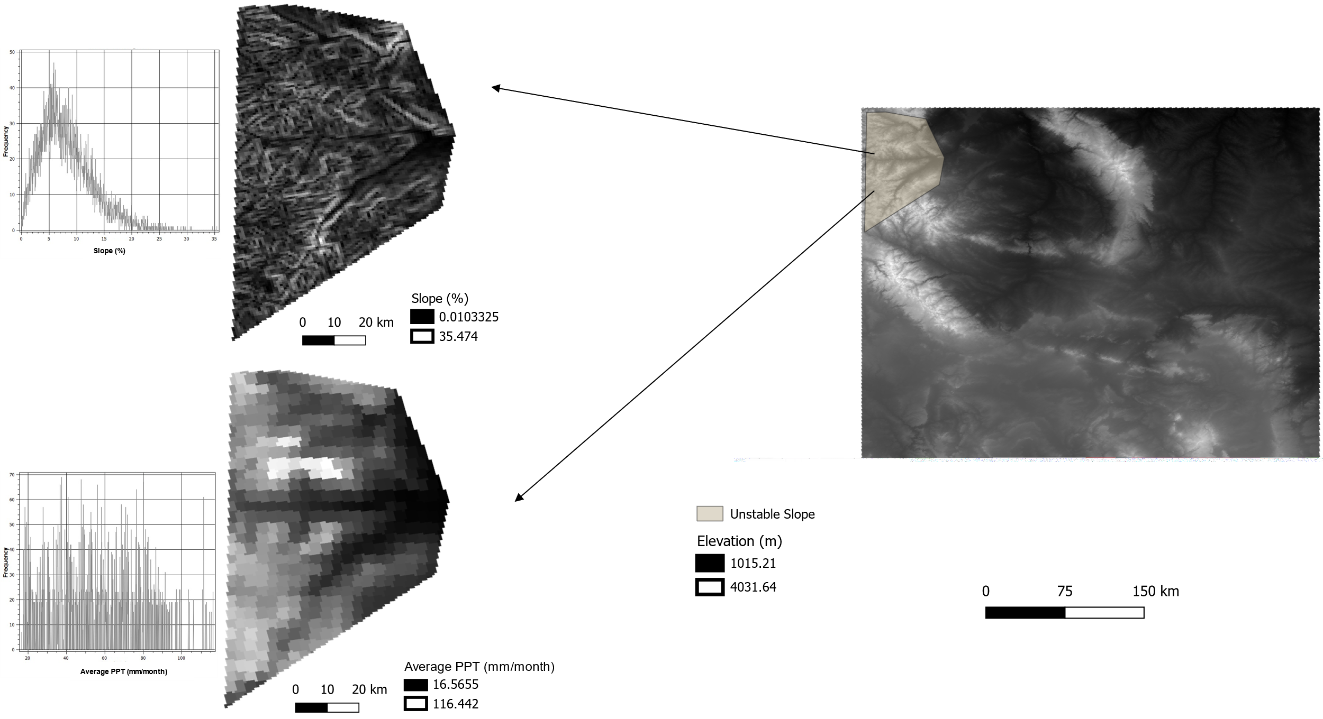

**Figure 2.** Slope stability analysis for the highlighted region. The mean slope and precipitation are approximately 8% and 56 mm/month, respectively. Here, we use the PRISM ‘ppt’ band as it is a higher resolution product than GPM. These maps are shown in UTM 15 N WGS84 projection system.

**Table 1.** Minimum and maximum total precipitation values over the entire study area. The modified codes are provided in the attached ipynb file.

|  |  |  |  |
| --- | --- | --- | --- |
| **Data** | **Band** | **Minimum (mm)** | **Maximum (mm)** |
| PRISM | ppt | 128.91 | 558.16 |
| GPM | precipitation | 161.32 | 305.84 |

**Table 2.** Minimum, maximum, and average precipitation values over the entire study area.

|  |  |  |  |  |
| --- | --- | --- | --- | --- |
| **Data** | **Band** | **Minimum (mm/month)** | **Maximum (mm/month)** | **Mean (mm/month)** |
| PRISM | ppt | 6.56 | 116.44 | 24.37 |
| GPM | precipitation | 11.47 | 32.47 | 19.37 |

**Figure 3.** GPM vs PRISM precipitation color coded with elevation data.

GPM shows high correlation with PRISM at lower elevations (< 2000 m). However, at higher elevations we see increased scatter.

**PART 2**

Here, we choose a part of the Wilcox groundwater basin in southern Arizona (Conway, 2016) as the study area.

|  |  |  |
| --- | --- | --- |
|  |  |  |
| (a) | (b) | (c) |

**Figure 4.** Screenshots of (a) normalized difference vegetation index (NDVI), (b) normalized difference moisture index (NDMI), and (c) enhanced vegetation index (EVI).

$$NDVI=\frac{NIR-RED}{NIR+RED}= \frac{B5-B4}{B5+B4}$$

$$NDMI= \frac{NIR-SWIR}{NIR+SWIR}= \frac{B5-B6}{B5+B6}$$

$$EVI=2.5* \frac{B5-B4}{B5+6 *B4-7.5*B2+1}$$

**Table 3.** Landsat 8 band names, wavelengths, and resolutions.

|  |  |  |  |
| --- | --- | --- | --- |
| **Band** | **Name** | **Wavelength ($μ$ m)** | **Resolution (m)** |
| B2 | Blue | 0.45-0.51 | 30 |
| B4 | Red | 0.64-0.67 | 30 |
| B5 | Near Infrared (NIR) | 0.85-0.88 | 30 |
| B6 | Shortwave IR 1(SWIR 1) | 1.57-1.65 | 30 |

The above formulas are used to calculate the corresponding indices where $B_{i}$ s correspond to Landsat 8 bands acquired during April to September 2020 (growing season).

From Figure 4, we observe that NDVI does quite well to delineate agricultural lands (deep red) in the Wilcox basin. NDMI is sensitive to vegetation water content and thus also picks up agricultural lands as wells as other plants. EVI does not do well because it is more sensitive in humid areas with dense vegetation. Since this region is arid, tropospheric correction is typically not required. Noticeably, all the three indices have low values over the Wilcox Playa, a dry lakebed.

|  |  |
| --- | --- |
|  |  |
| (a) | (b) |

**Figure 5.** Maps of (a) slope and (b) average monthly precipitation in Wilcox basin from April-September 2020 shown in UTM 12 N WGS84 projection system.

Since there is very low precipitation in this area, rainfall-induced landslides are generally not common. However, this region experiences one of the highest land-subsidence rates in Arizona due to excessive groundwater withdrawals (Conway, 2016).

**Table 4.** Minimum and maximum total precipitation values over Wilcox basin (April-September 2020). The modified codes are provided in the attached ipynb file.

|  |  |  |  |
| --- | --- | --- | --- |
| **Data** | **Band** | **Minimum (mm)** | **Maximum (mm)** |
| PRISM | ppt | 50.04 | 53.07 |
| GPM | precipitation | 69.72 | 85.65 |

**Table 5.** Minimum, maximum, and average precipitation values over Wilcox basin (April-September 2020).

|  |  |  |  |  |
| --- | --- | --- | --- | --- |
| **Data** | **Band** | **Minimum (mm/month)** | **Maximum (mm/month)** | **Mean (mm/month)** |
| PRISM | ppt | 7.63 | 22.25 | 12.8 |
| GPM | precipitation | 11.86 | 18.9 | 15.1 |

**Figure 6.** GPM vs PRISM precipitation color coded with elevation data. Wilcox is an arid region, and the study area is not big enough to have an appropriate scatter plot comparison because of the coarser resolution of the GPM precipitation data.

**References**

Conway, B. D. (2016). Land subsidence and earth fissures in south-central and southern Arizona, USA. *Hydrogeology Journal*, *24*(3), 649–655. https://doi.org/10.1007/s10040-015-1329-z